**CDAC MUMBAI**

**Concepts of Operating System**

**Assignment 2**

**Part A**

**What will the following commands do?**

**• echo "Hello, World!" ----- Prints Hello, World!**

**• name="Productive"------Nothing happens**

**• touch file.txt----- Creates file.txt**

**• ls -a ----Show hidden files**

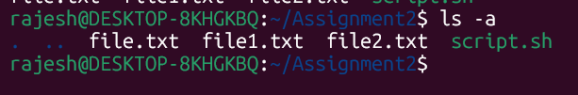

**• rm file.txt ---- Remove File.txt**

**• cp file1.txt file2.txt ----- file1.txt files details copied and creates file2.txt with same details**

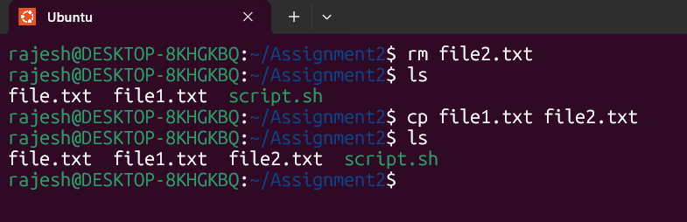

**• mv file.txt /path/to/directory/---- mv file.txt /path/to/directory/**

**mv: cannot move 'file.txt' to '/path/to/directory/': No such file or directory**



**• chmod 755 script.sh -------** **It is used to change the file permissions of script.sh**



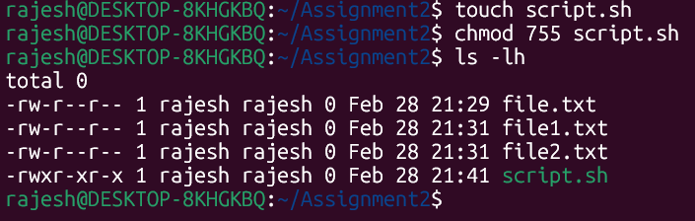

**• grep "pattern" file.txt ----- searches for "pattern" inside file.txt and prints matching lines**

**• kill PID----** 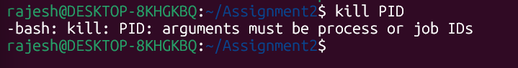

**• mkdir mydir && cd mydir && touch file.txt && echo "Hello, World!" > file.txt && cat file.txt**

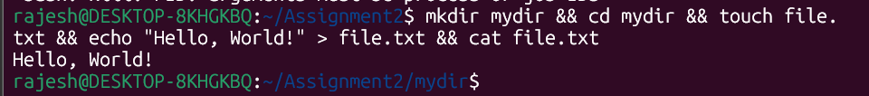

**• && → Runs the next command only if the previous one succeeds.**

**• > → Redirects output to a file (overwrites existing content).**

**• cat → Reads and prints the content of a file.**

**• ls -l | grep ".txt"**

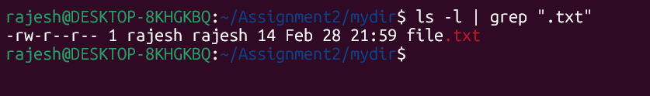

* **Ls -l • Lists files and directories in long format (permissions, owner, size, date, etc.).**
* **| (Pipe Operator) • Sends the output of ls -l as input to grep.**
* **grep ".txt" Filters the list to show only files containing .txt in their names.**

**• cat file1.txt file2.txt | sort | uniq**

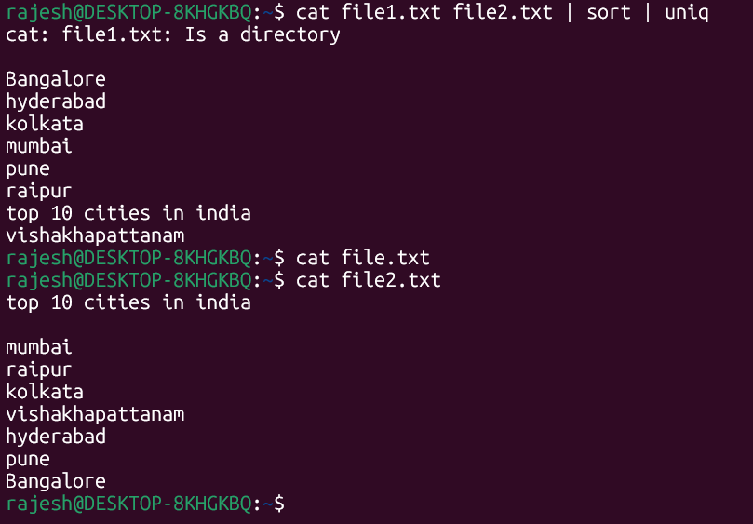

**Copy the file of file1.txt into file2.txt with its content**

**is used to combine, sort, and remove duplicate lines from two text files**

**• ls -l | grep "^d"**

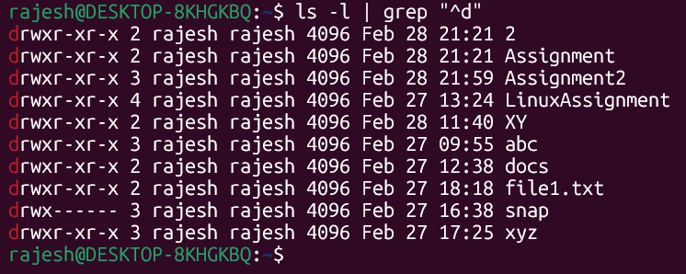

* **Lists files and directories in long format (permissions, owner, size, date, etc.).**

**•**

**• grep -r "pattern" /path/to/directory/**

**• cat file1.txt file2.txt | sort | uniq –d**



**• chmd 644 file.txt**

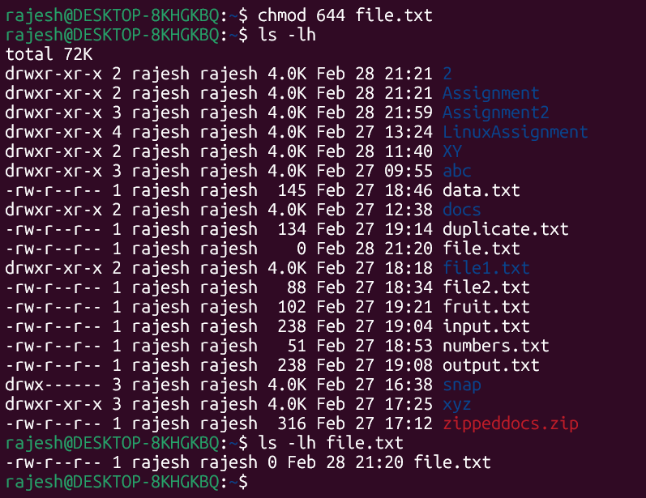

**• cp -r source_directory destination_directory – copies the abc folder inside snap folder**

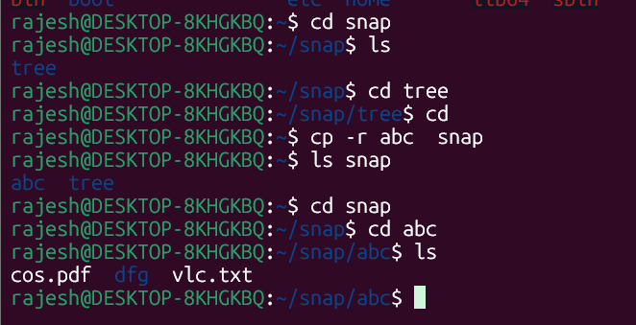

**• find /path/to/search -name "*.txt"**

**• chmod u+x file.txt**

**• echo $PATH**

**Part B**

**Identify True or False:**

**1. ls is used to list files and directories in a directory. True**

**2. mv is used to move files and directories. True**

**3. cd is used to copy files and directories. False**

**4. pwd stands for "print working directory" and displays the current directory. True**

**5. grep is used to search for patterns in files. True**

**6. chmod 755 file.txt gives read, write, and execute permissions to the owner, and read and execute**

**permissions to group and others. True**

**7. mkdir -p directory1/directory2 creates nested directories, creating directory2 inside directory1**

**if directory1 does not exist. True**

**8. rm -rf file.txt deletes a file forcefully without confirmation. True**

**Identify the Incorrect Commands:**

**1. chmodx is used to change file permissions. Incorrect**

**2. cpy is used to copy files and directories. Incorrect**

**3. mkfile is used to create a new file. . Incorrect**

**4. catx is used to concatenate files. . Incorrect**

**5. rn is used to rename files. . Incorrect**

**Part C**

**Question 1: Write a shell script that prints "Hello, World!" to the terminal.**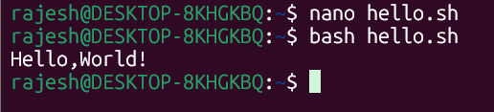

**Question 2: Declare a variable named "name" and assign the value "CDAC Mumbai" to it. Print the**

**value of the variable.**

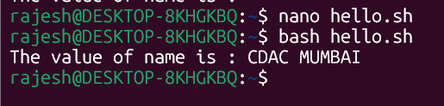

**Question 3: Write a shell script that takes a number as input from the user and prints it.**

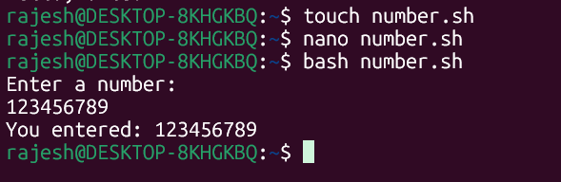

**Question 4: Write a shell script that performs addition of two numbers (e.g., 5 and 3) and prints the**

**result.**

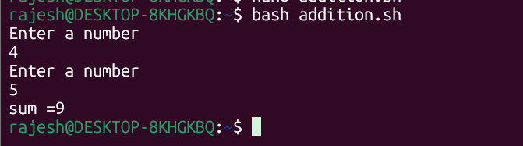

**Question 5: Write a shell script that takes a number as input and prints "Even" if it is even, otherwise**

**prints "Odd".**

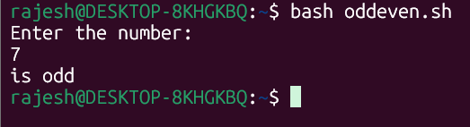

**Question 6: Write a shell script that uses a for loop to print numbers from 1 to 5.**

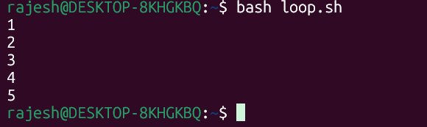

**Question 7: Write a shell script that uses a while loop to print numbers from 1 to 5.**

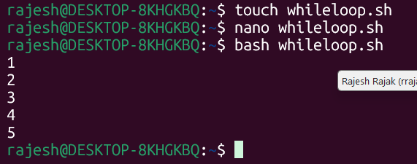

**Question 8: Write a shell script that checks if a file named "file.txt" exists in the current directory. If it**

**does, print "File exists", otherwise, print "File does not exist".**

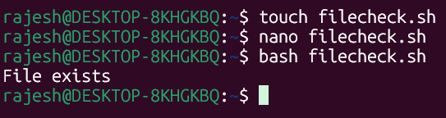

**Question 9: Write a shell script that uses the if statement to check if a number is greater than 10 and**

**prints a message accordingly.**

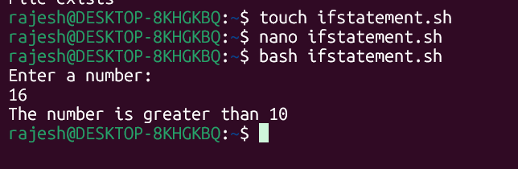

**Question 10: Write a shell script that uses nested for loops to print a multiplication table for numbers**

**from 1 to 5. The output should be formatted nicely, with each row representing a number and each**

**column representing the multiplication result for that number.**

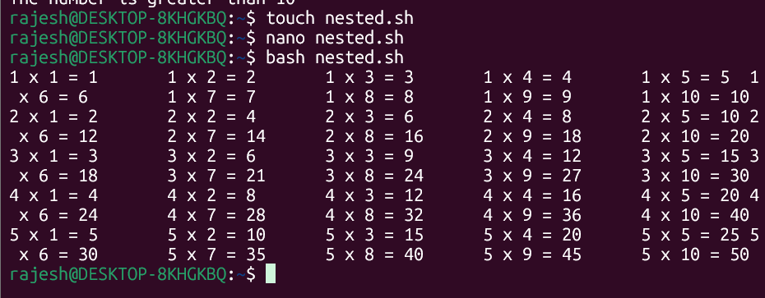

**Question 11: Write a shell script that uses a while loop to read numbers from the user until the user enters**

**a negative number. For each positive number entered, print its square. Use the break statement to exit the**

**loop when a negative number is entered.**

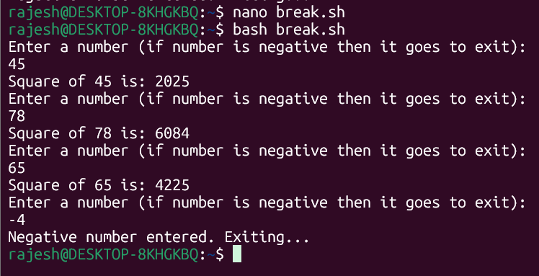

**Part E**

1. Consider the following processes with arrival times and burst times:

| Process | Arrival Time | Burst Time |

|---------|--------------|------------|

| P1 | 0 | 5 |

| P2 | 1 | 3 |

| P3 | 2 | 6 |

Calculate the average waiting time using First-Come, First-Served (FCFS) scheduling

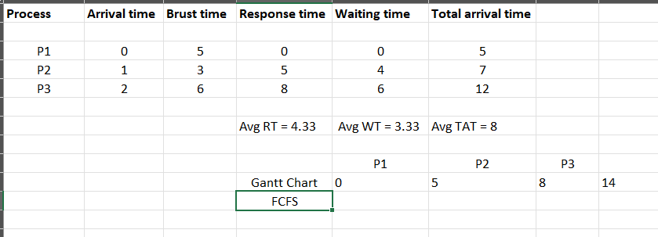

2. Consider the following processes with arrival times and burst times:

| Process | Arrival Time | Burst Time |

|---------|--------------|------------|

| P1 | 0 | 3 |

| P2 | 1 | 5 |

| P3 | 2 | 1 |

| P4 | 3 | 4 |

Calculate the average turnaround time using Shortest Job First (SJF) scheduling.

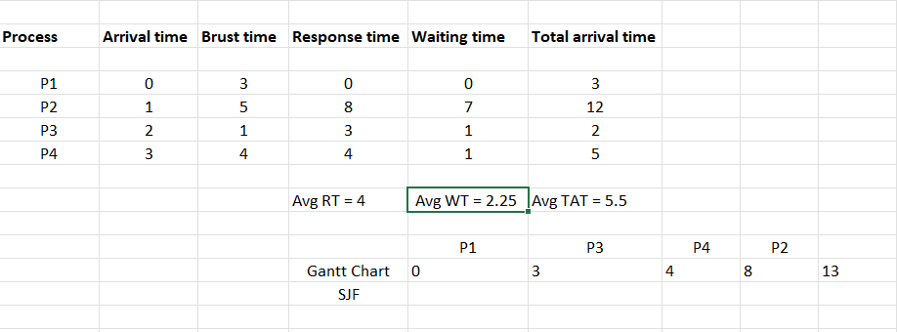

3. Consider the following processes with arrival times, burst times, and priorities (lower number

indicates higher priority):

| Process | Arrival Time | Burst Time | Priority |

|---------|--------------|------------|----------|

| P1 | 0 | 6 | 3 |

| P2 | 1 | 4 | 1 |

| P3 | 2 | 7 | 4 |

| P4 | 3 | 2 | 2 |

Calculate the average waiting time using Priority Scheduling.

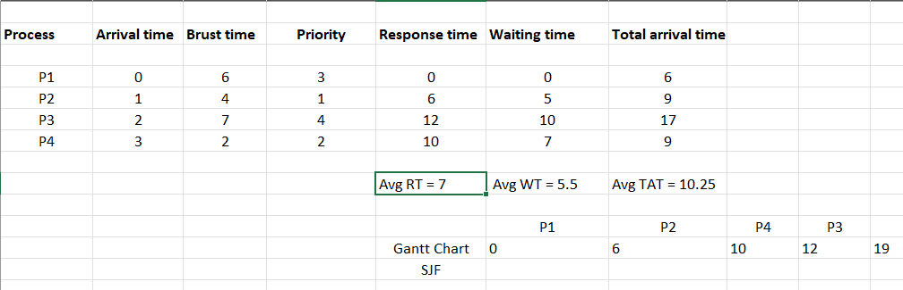

4. Consider the following processes with arrival times and burst times, and the time quantum for

Round Robin scheduling is 2 units:

| Process | Arrival Time | Burst Time |

|---------|--------------|------------|

| P1 | 0 | 4 |

| P2 | 1 | 5 |

| P3 | 2 | 2 |

| P4 | 3 | 3 |

Calculate the average turnaround time using Round Robin scheduling.

